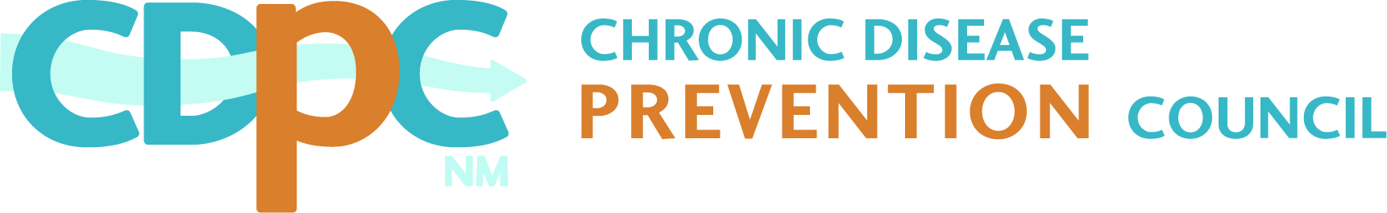
Membership Form

Purpose: To serve as a coordinating body for addressing chronic disease prevention in
New Mexico.
Mission: To reduce common risk factors for the chronic diseases* of arthritis, cancer,
cardiovascular disease, diabetes, lung disease, and osteoporosis by:
- Advocating for prevention policies and programs
- Facilitating collaboration among agencies and organizations working to prevent and/or manage chronic disease
- Supporting initiatives to understand, identify and address social determinants
that impact chronic disease
*As identified by the National Association of Chronic Disease Directors.

Member Name/Title:
Organization (if applicable) **:
Mailing Address:
Email Address: |  |  |  |  |  |  |  | Telephone:
Date: |  |  |  |  |  | Signature:
Website (will be included on the CDPC resources website page):

By signing this form, the Member acknowledges that they are expected to attend at least two of the four quarterly meetings of Members in each calendar year (members may send an alternate or representative in their place).

**As it should appear on CDPC correspondence.

CDPC Membership Type:

Yes, I want to be an individual voting member of the CDPC.
Yes, my organization designates me to be the voting member of the CDPC.***
Yes, I want to be a non-voting organizational member of the CDPC.

*** If the Member is representing an organization, the Member hereby confirms, on behalf of the organization, that he/she has been duly designated by the organization to serve as its authorized representative for purposes of taking all actions of the organization in its capacity as a Member (i.e. Councils & Coalitions current Chair/Director will have voting privileges for their organization).

CDPC Correspondence Endorsement Check-Off:

I authorize the NM Chronic Disease Prevention Council to include my organization’s name on any correspondence supporting policy and legislation in support of the CDPC Mission.
I cannot authorize the NM Chronic Disease Prevention Council to include my organization’s name on any correspondence supporting policy and legislation in support of the CDPC Mission.
On a case-by-case basis, I may authorize the NM Chronic Disease Prevention Council to include my organization’s name on correspondence supporting policy and legislation in support of the CDPC Mission.

Please check any of the workgroups you would like to be a part of:

 | Childhood Obesity Workgroup |  | Prediabetes Workgroup |  | New Mexico Council on  Asthma Workgroup
 | Communications Workgroup |  | New Mexico Allied Council on Tobacco (NMACT) Workgroup
 | Million Hearts® Workgroup |  | Youth Health Equity Workgroup

Send membership form to: Laurel McCloskey
Chronic Disease Prevention Council
P.O. Box 3511, Albuquerque, NM 87190
(505) 463-5300, laurel@chronicdiseasenm.org
www.chronicdiseasenm.org

