New Mexico Prediabetes and Diabetes Facts
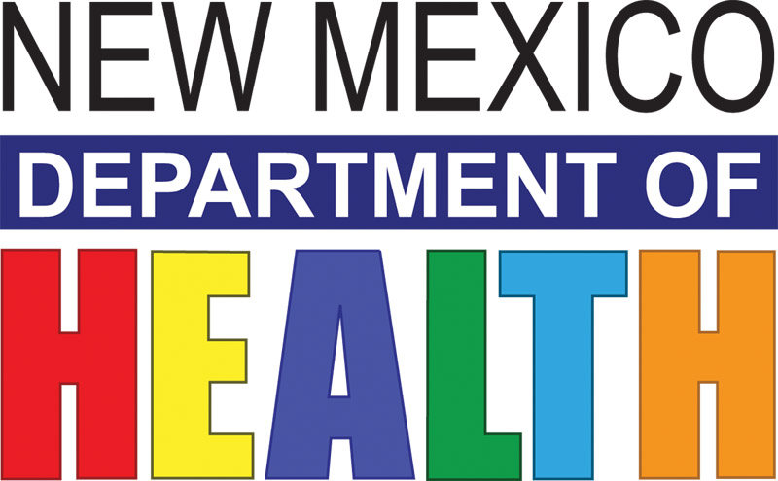

Definitions
Prediabetes occurs when a person’s blood sugar is higher than normal but not as high as it would be with diabetes, and there may be no external symptoms of disease.
Diabetes is a group of diseases marked by high levels of blood sugar due to defects in insulin production, insulin action, or both.
Prevalence is the percentage of the population that has a certain existing condition.

Prediabetes
Although prediabetes is a precursor to diabetes, evidence shows that some people with prediabetes can return their blood sugar to normal levels, preventing or delaying progression to diabetes. People with prediabetes also have an increased risk of developing heart disease and stroke. Data from the telephone-based New Mexico (NM) Behavioral Risk Factor Surveillance System (BRFSS) show that 7.8% or 122,500 of NM adults aged 18 and older had diagnosed prediabetes in 2012-2013.

Table 1: Estimated Diagnosed Prediabetes Prevalence (%) 2012-2013, NM BRFSS
Have you ever been told by a doctor or other health professional that you have prediabetes or borderline diabetes?

 | Percent of Adults |  |  | Percent of Adults
New Mexico | 7.8 |  | Health Region
Female | 7.5 |  | Northwest | 9.1
Male | 8.2 |  | Northeast | 8
 |  |  | Metro | 8.2
Age Group |  |  | Southeast | 7.2
18-39 years | 4.1 |  | Southwest | 6.6
40-59 years | 9.4
60 years & older | 11.9
Household Income |  |  | Race/Ethnicity
< $15,000 | 9.7 |  | American Indian/Alaska Native | 12.6
$15-24,999 | 9.2 |  | Asian/Native Hawaiian /Other Pacific Isle* | 3.1
$25-34,999 | 8.8 |  | Black/African American | 12.3
$35-49,999 | 6.6 |  | Hispanic | 8.9
> $50,000 | 6.8 |  | White | 6.3
Data Source: New Mexico Department of Health, Behavioral Risk Factor Surveillance System (BRFSS), 2012 & 2013.
Two years of data are used to increase the reliability of some of the rates. All rates except age group rates are age-adjusted to the 2000 US standard. * This estimated rate should not be used to describe population/group risk because it is statistically unreliable.

Prediabetes Prevalence
Table 1 shows NM rates of diagnosed prediabetes by population characteristics. The older the age group, the higher the prevalence: the oldest age group (60 & older) rate was 2.9 times higher than the youngest age group (18-39) rate. The lower the household income, the higher the prediabetes prevalence. The lowest household income group (<$15,000) rate was 47% higher than $35-49,999 rate. The American Indian and Black rates were twice the White rate. These differences in rates are all statistically significant.

Diabetes
Uncontrolled diabetes can lead to serious complications and premature death. However, people with diabetes can successfully manage their diabetes and lower their risk for developing complications.

Table 2: Estimated Diagnosed Diabetes Prevalence (%) 2012-2013, NM BRFSS
Has a doctor, nurse, or other health professional EVER told you that you have diabetes?

 | Percent of Adults |  |  | Percent of Adults
New Mexico | 9.6 |  | Health Region
Female | 9.2 |  | Northwest | 12.1
Male | 10.1 |  | Northeast | 7.3
 |  |  | Metro | 8.8
Age Group |  |  | Southeast | 11.0
18-39 years | 2.0 |  | Southwest | 10.9
40-59 years | 12.1
60 years & older | 20.1
Household Income |  |  | Race/Ethnicity
< $15,000 | 15.2 |  | American Indian/Alaska Native | 18.1
$15-24,999 | 11.8 |  | Asian/Native Hawaiian /Other Pacific Isle* | 8.4
$25-34,999 | 11.1 |  | Black/African American | 9.0
$35-49,999 | 9.4 |  | Hispanic | 12.6
> $50,000 | 5.8 |  | White | 6.1
Data Source: New Mexico Department of Health, Behavioral Risk Factor Surveillance System (BRFSS), 2012 & 2013. Two years of data are used to increase the reliability of some of the rates. All rates except age group rates are age-adjusted to the 2000 US standard.

Diabetes Prevalence
Table 2 shows 2012-2013 NM rates of diagnosed diabetes by population characteristics. Similar to prediabetes prevalence and true for many chronic conditions, the older the age group, the higher the prevalence. The 60+ age group had the highest prevalence, at 10 times that of the 18-39 age group and 1.7 times that of the 40-59 age group rate.

Generally, the lower the household income, the higher the diabetes prevalence. The lowest household income group (<$15,000) had the highest rate, while the highest household income group (>$50,000) had the lowest rate. The <$15,000 rate was 2.6 times higher than the rate for the >$50,000 group and 1.3 times higher than the $15-24,999 rate.
Among NM Health Regions, the Northwest Region had the highest rate while the Northeast and Metro Regions had the lowest rates. Among NM’s racial/ethnic groups, rates from high to low are as follows: American Indian/Alaska Native, Hispanic, and White. The American Indian rate was three times, and the Hispanic rate was two times, the White rate.

Diabetes Deaths
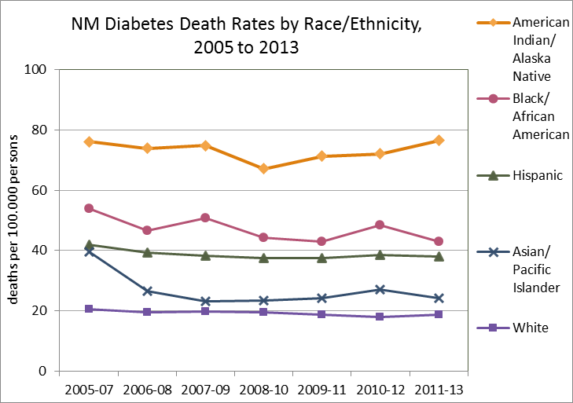
The figure on the right shows nine-year trends of diabetes death rates for NM’s racial/ethnic groups. Significant differences remained throughout the nine-year period. The American Indian/Alaska Native rates remained about four times the White rates and about two times the Hispanic rates. Hispanic rates remained twice that of White rates. These differences are statistically significant. From 2005 to 2013, a total of 5,498 diabetes deaths occurred, with a yearly average of 611 deaths. There were 2,399 Hispanic, 2,141 White, 771 American Indian, 133 Black, and 46 Asian/Pacific Islander diabetes deaths.

What Works to Prevent or Delay Diabetes
People at high risk for diabetes, including those with prediabetes, may prevent or delay the onset of diabetes by losing a modest amount of weight (5-7% of body weight), increasing physical activity (at least 150 minutes per week) and adopting a healthier diet. The National Diabetes Prevention Program (www.cdc.gov/diabetes/prevention) is a proven intervention to help people at high risk for diabetes achieve these lifestyle changes and is being implemented throughout the US and NM.

Prediabetes and Diabetes: Other Significant Factors
Smoking can increase blood pressure, decrease levels of good cholesterol (HDL), and increase insulin resistance; smoking also plays a role in the development of type 2 diabetes. Smoking further raises the already higher risk of heart disease or stroke in adults with prediabetes or diabetes. According to the BRFSS, in 2012-13, 19.2% of NM adults currently smoked. Among NM adults with prediabetes, 23.1% smoked and among adults with diabetes, 23.9% smoked. These rates are statistically similar, that is, all three groups had similar rates of smoking.

Prediabetes and diabetes are often undiagnosed. Telephone surveys capture only those who report having been diagnosed with these conditions, and these groups are small compared to the groups whose prediabetes or diabetes have not been diagnosed.

Data from the National Health and Nutrition Examination Survey (2009-2012), which identifies people with both diagnosed and undiagnosed prediabetes, show that about 37% of US adults ages 20 and older actually have prediabetes. Based on this estimate, in 2012-13 about 558,760 NM adults 20 years and older -- 1 in 3 -- had prediabetes, most without knowing it. Using the same source, an estimated 13.2% or 169,340 of NM adults 18 and older had either diagnosed or undiagnosed diabetes in 2012-13. NM’s total estimate for both of these conditions surpasses 728,000 adults.
Prediabetes in NM:
1 in 3 Adults = 558,760

Resources
For information the National Diabetes Prevention Program, go to: www.cdc.gov/diabetes/prevention
For information about diabetes prevention and prediabetes, go to: http://www.cdc.gov/diabetes/data/statistics/2014StatisticsReport.html

Go to http://nmhealth.org/about/phd/cdb/dpcp/ to access a prediabetes screening test.
Go to http://archive.diabetesnm.org/ for these online courses:
- A free online course for providers about prediabetes; and
- A training guide to implementing community walking trails
- Free online courses for providers on Diabetes and Smoking and Diabetes and Depression

For more information about diabetes and what works to prevent and control diabetes, go to: www.thecommunityguide.org/diabetes/index.html and http://ibis.health.state.nm.us/indicator/complete_profile/DiabPrevl.html

References
Centers for Disease Control and Prevention. National Diabetes Statistics Report: Estimates of Diabetes and Its Burden in the United States, 2014. Atlanta, GA: U.S. Department of Health and Human Services; 2014. http://www.cdc.gov/diabetes/pubs/statsreport14/national-diabetes-report-web.pdf

NM Diabetes Prevention and Control Program
Judith Gabriele, program manager, 505-476-7613, judith.gabriele@state.nm.us
Corazon Halasan, program epidemiologist, 505-476-7617, corazon.halasan@state.nm.us
Chris Lucero, coordinator of evidence-based programs, 505-222-8605, christopher.lucero@state.nm.us

May 2015

