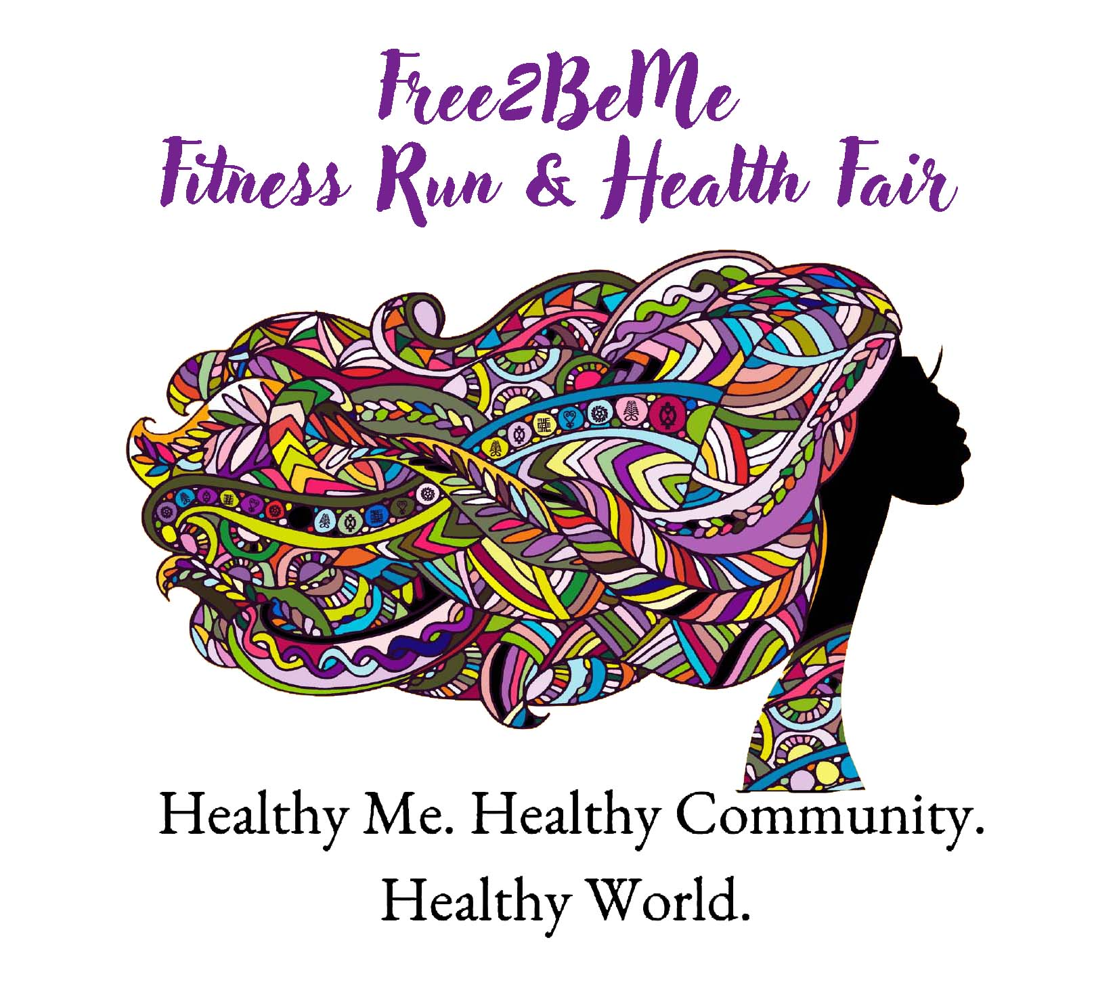  May 30th, Memorial Day  Free2BeMe Fitness Run & Health Fair  This Memorial Day, run, walk, or stroll over to Tin Can Alley to join the 10k, 5k or Children’s 1k race, celebrate healthy choices, learn about new neighbors, discover new organizations, and express yourself fully in the Free2BeMe Costume Contest.  Find out more: Register now :  Xxxx  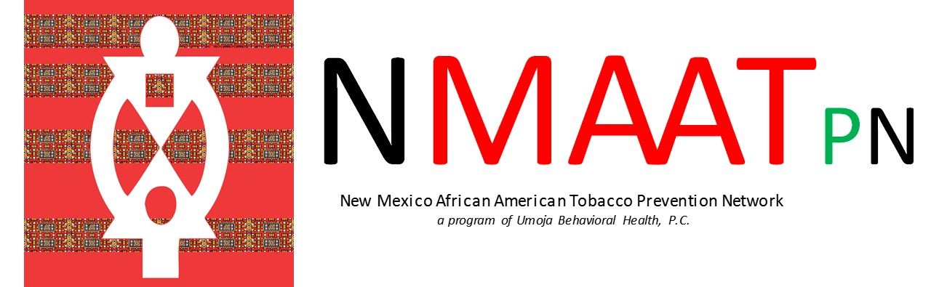  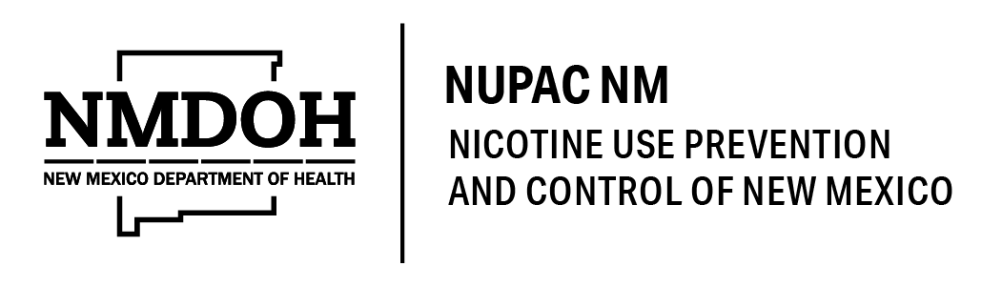  HEART & SOLE SPORTS | Register for 10k, 5k or Kids 1k Races  ────  Costume Contest? Ya Betcha…  ────  20 Vendors Peddling Health & Wellness  ────  CV19 Vaccinations, healthcare information, & more  ────  Collecting non-perishables for the Road Runner Food Bank!  TCR Productions  Register for the Race at  https://register.chronotrack.com/r/66604  Find Out More:  https://nmaatp.com/free2beme

